June is National Indigenous History Month! We’re celebrating by focusing on our [collection of Inuit ceramics](http://emuseum.gardinermuseum.on.ca/search/inuit) from Rankin Inlet, Nunavut. The collection highlights the creativity and rich living history of Inuit peoples.

The works in our collection use low-relief storytelling to express stories about Inuit culture and beliefs. Artists like Yvo Samgushak, Rodger Aksaduak, and John Kurok were inspired by the stories they were told by their ancestors, as well as their daily interactions with animals and the landscape.

Low-relief is a sculptural technique where raised elements are attached to a solid background of the same material, giving it a 3D appearance. Karin Pavey, one of pottery instructors, shows you the steps to tell your own low-relief story on a pinch pot. What’s a story that you would like to tell?

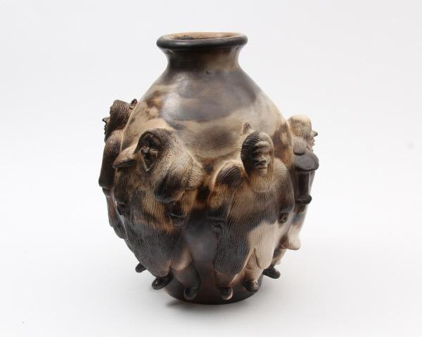

**Materials:**

* A large piece of clay or modelling material. Use one of our [5 recipes for homemade clay](https://www.gardinermuseum.on.ca/wp-content/uploads/Clay-Recipes.pdf)
* Tools for cutting and shaping like chopsticks, wooden skewers, Popsicle sticks, a plastic knife, old paint brushes, a rolling pin, and toothpicks

**Instructions:**

Divide your clay into 3 parts. Roll the first piece into a ball.

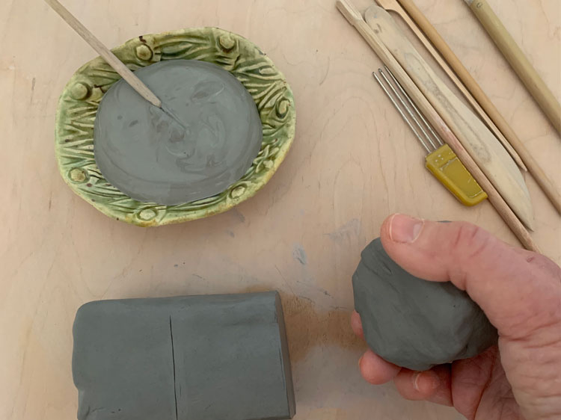

Poke your thumb into the centre of the ball, but don’t press it all the way through.

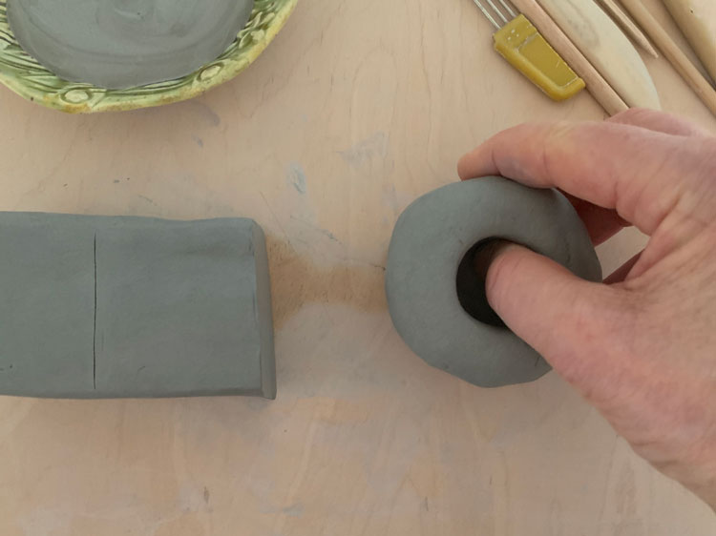

“Pinch” out the bowl using your fingers and thumb.

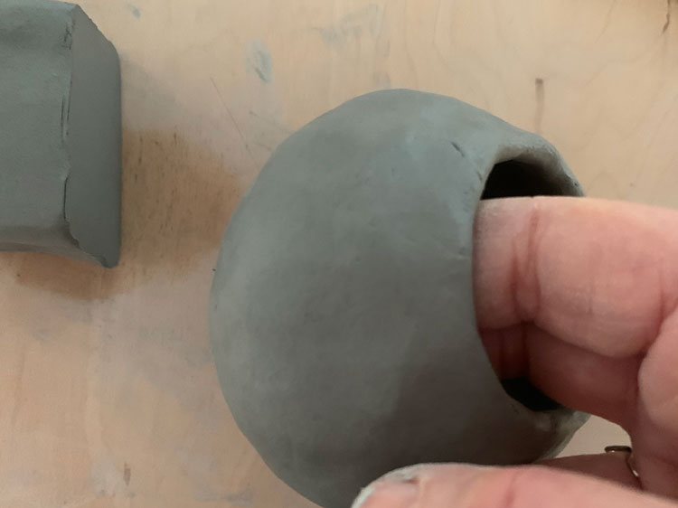

Take your second piece of clay and soften it by squeezing it. Use a rolling pin to flatten this piece to a thickness of around half a centimetre.

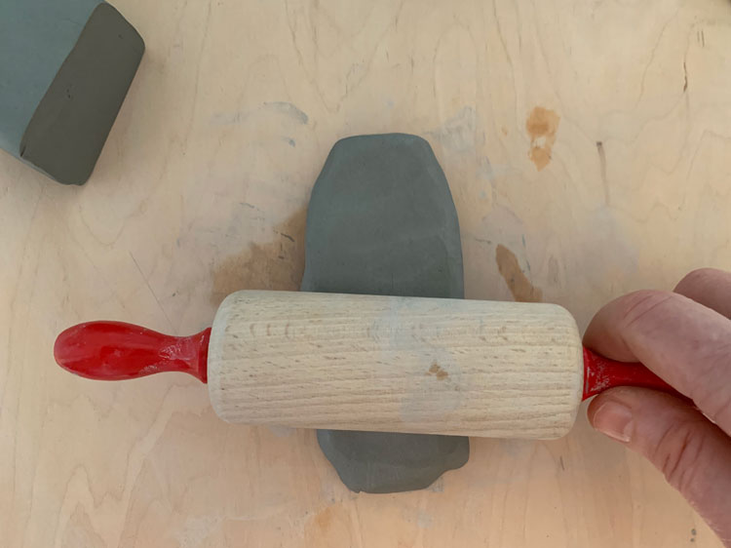

Cut the sides into a rectangle using a plastic knife and ruler if you have one. This flat piece will be the “neck” of your vessel. You want this neck to be proportional to the size of your pinch pot.

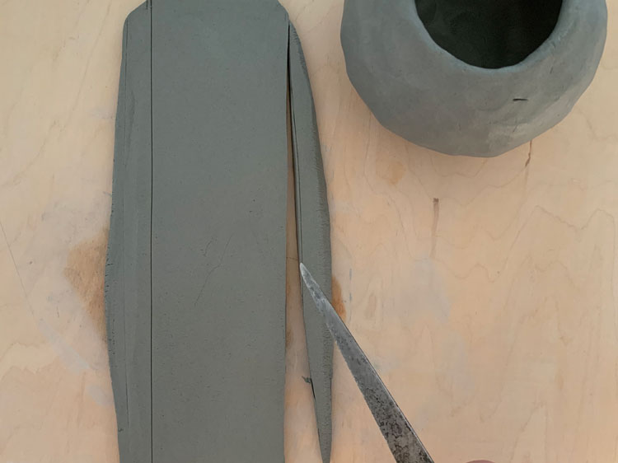

Place this neck piece on top of the pinch pot and measure. Overlap the excess length.

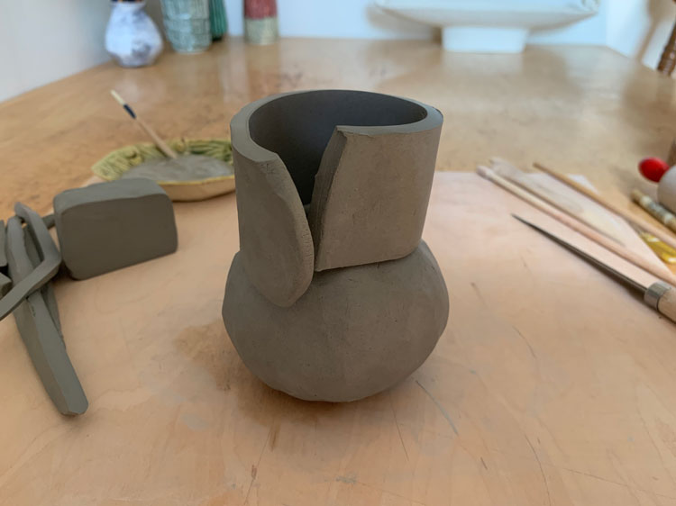

Cut the excess length on an angle. Recycle the scraps.

Remove the neck and “score” the edges. Using a sharp tool like a toothpick to “score” or scratch the surface of the bowl where you will place your neck. Then scratch the edges of your neck piece.

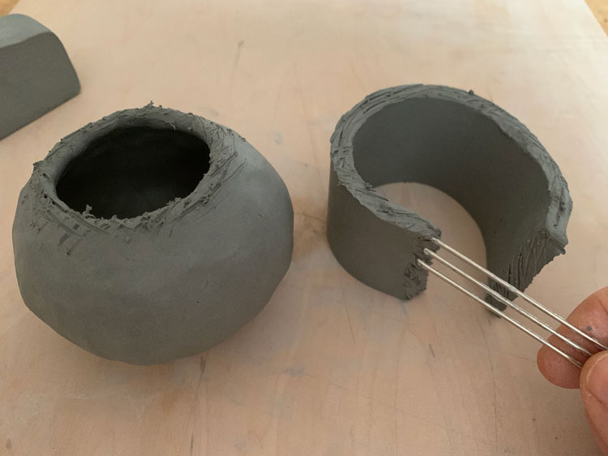

Apply a bit of water to both scratched surfaces. This will help them stick together.

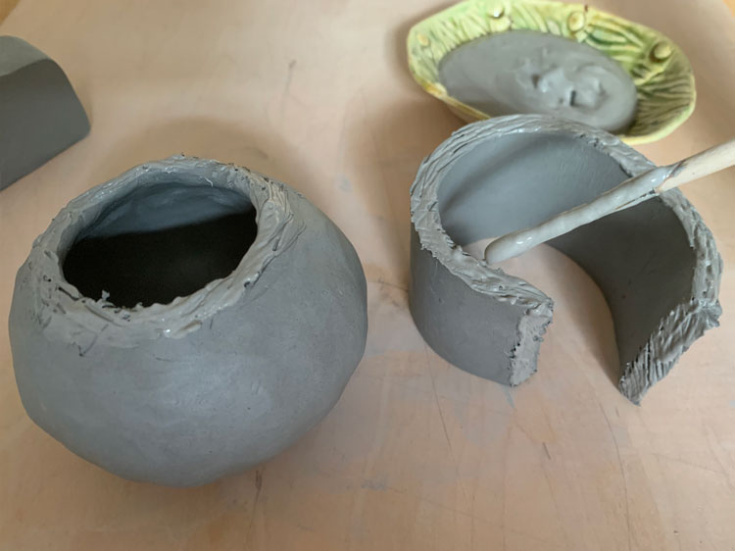

Gently stick the ends of the neck together to create a tube.

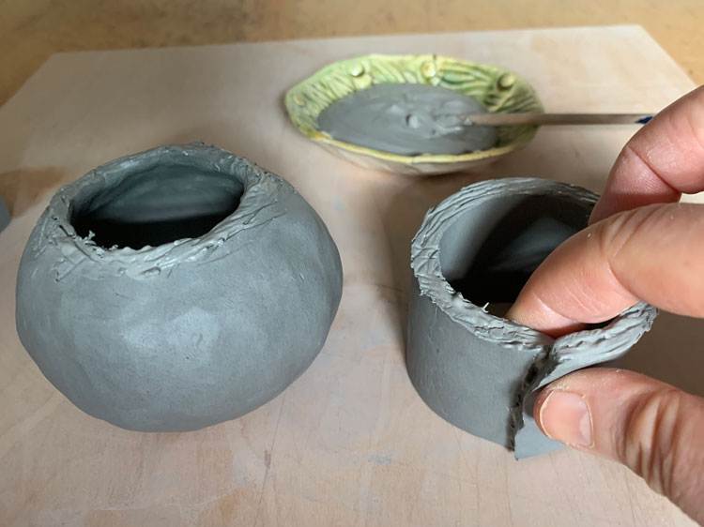

Then gently stick the neck to the pinch pot bowl.

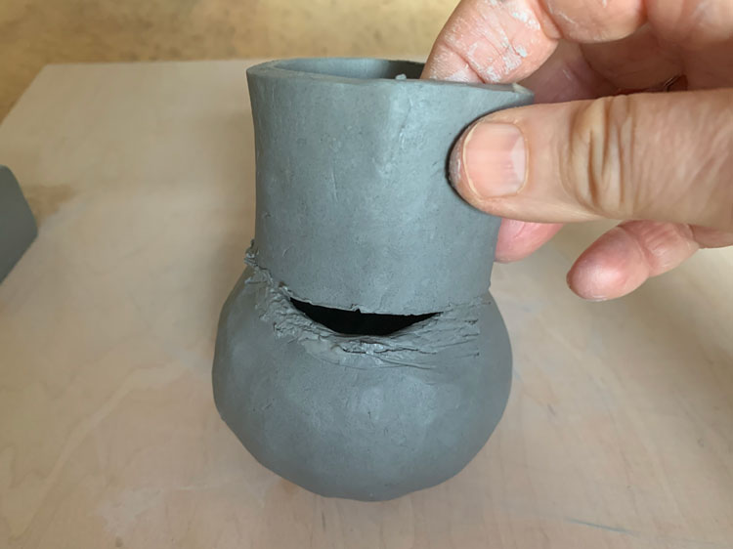

Using your fingers, smooth out the joints of the neck. You want them to be firm. You can use a smoothing tool if you have one, but your fingers will work just fine.

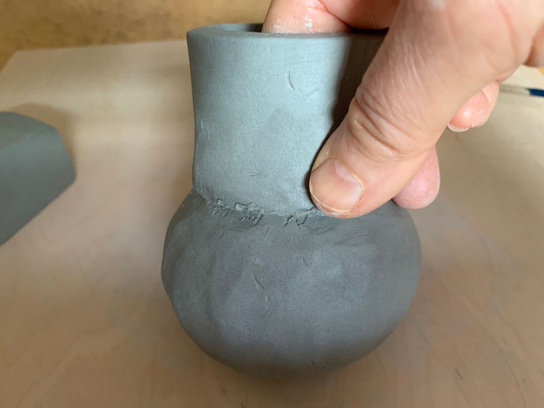

You can  pull the top of the neck slightly to create a flared lip.

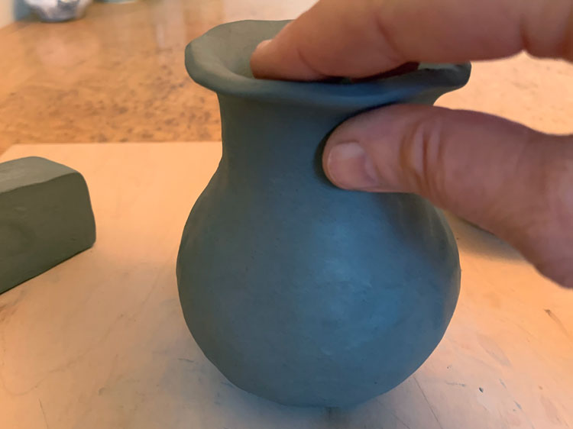

Roll out your last piece of clay to create your low-relief image. You don’t want it to be too thick or too thin.

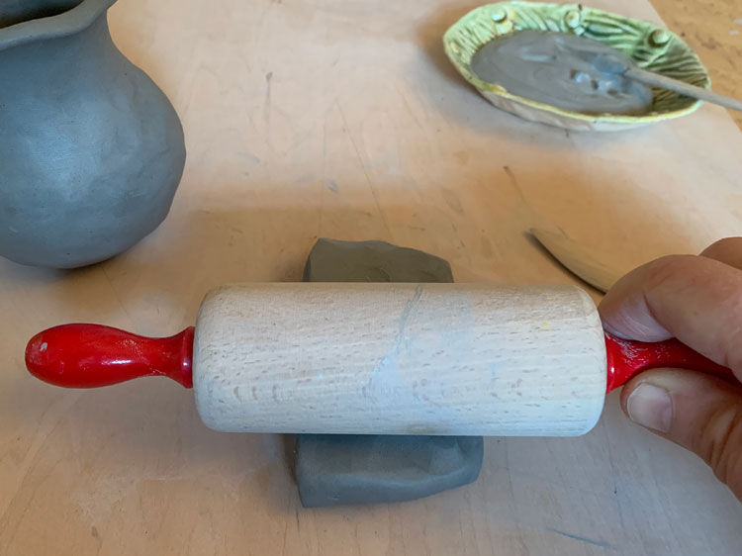

Use a skewer or butter knife to cut out one or two symbols or objects that will tell your story. Try something simple.

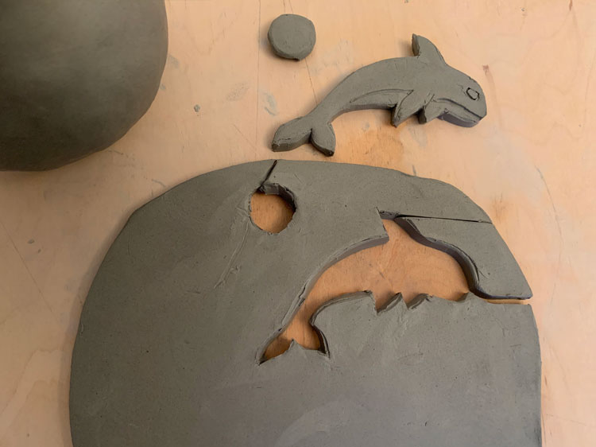

Score the back of your clay cut-out and the area on the pot where you’ll place it. Dab some water to both areas.

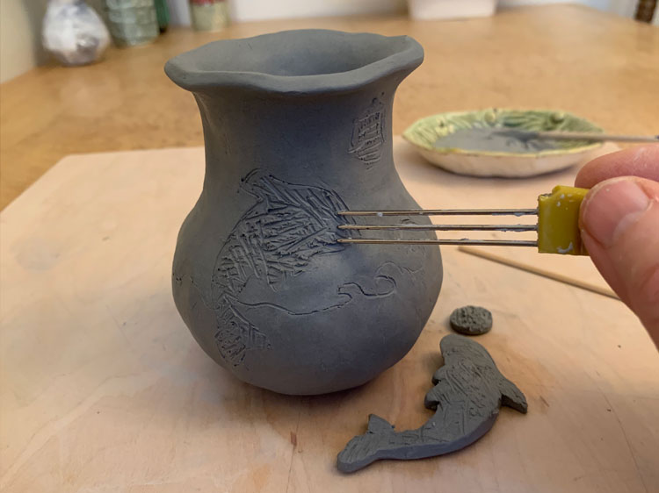

Apply your cut-out to your pot and press, smoothing out the edges with your fingers. You can also use a sponge to smooth out your clay.

Draw additional 2D images with a toothpick or skewer to give your symbols context.

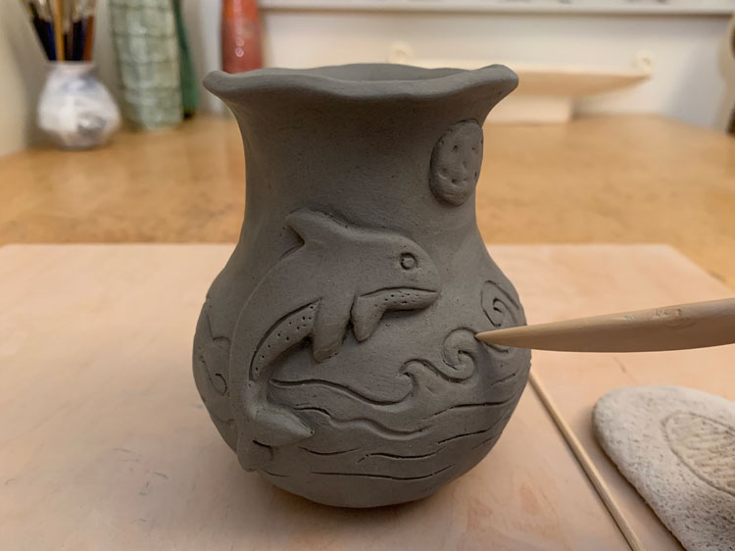

Take a photo and share with us using **#GardinerFromHome**.